**Tutorial****-2**

**1.Predict and write output for the following code.**

**Code**

using System;

namespace DecisionMaking

{

class Program

{

static void Main(string[] args)

{

/* local variable definition */

int a = 10;

/* check the boolean condition using if statement */

if (a < 20)

{

/* if condition is true then print the following */

Console.WriteLine("a is less than 20");

}

Console.WriteLine("value of a is : {0}", a);

Console.ReadLine();

}

}

}

**OUTPUT:**

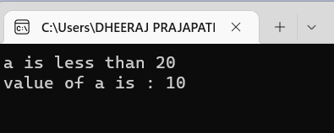

**2.** **Write missing statement to get the desired output.**

**Code:**

using System;

namespace DecisionMaking

{

class Program

{

static void Main(string[] args)

{

/* local variable definition */

int a = 100;

/* check the boolean condition */

if (a < 20)

{

/* if condition is true then print the following */

Console.WriteLine("a is less than 20");

}

else

{

Console.WriteLine(" a is not less than 20");

}

Console.WriteLine("Value of a is :100");

Console.ReadLine();

}

}

}

**OUTPUT:**

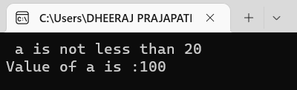

**3.** **Correct the following code and write output for the corrected code.**

**Code:**